**Test results:**

When entering a positive evaluation, google sentiment will automatically give me feedback analysis of the evaluation score, the higher the score, the greater the possibility of a positive evaluation

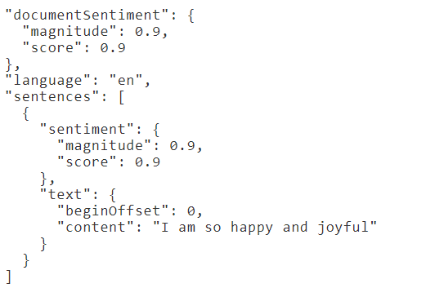

When the wording of the evaluation is modified, we can see that the use of the modifier does not have a particularly large effect on the results, indicating that the score indicates the degree of certainty that the evaluation is positive and has nothing to do with the degree of emotion

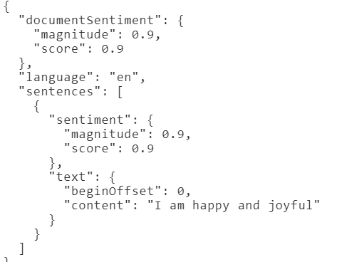

Similar words are interchanged with the same result

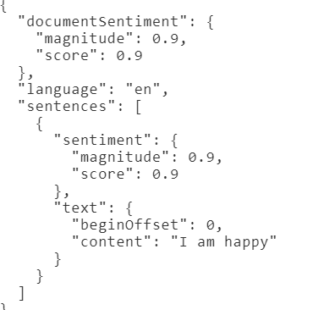

Similarly, when negative feelings are entered into the evaluation can also be detected

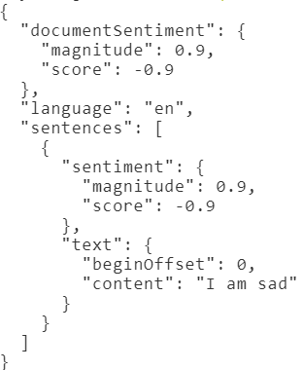

When both positive and negative comments appear in a sentence, the model is unable to categorize the comment as positive or negative

